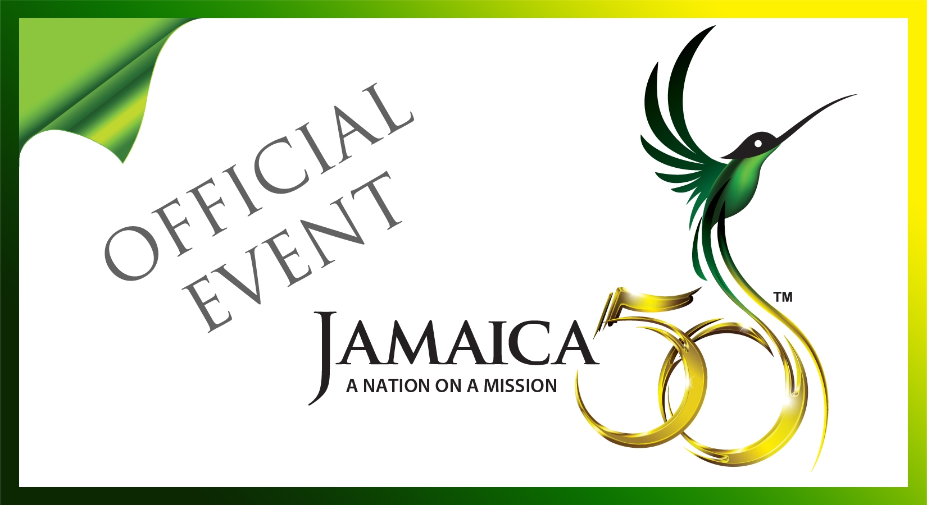

Jamaica 50 UK
Official Events

Date | Event | Venue | Contact | Email / Telephone
May 16  June 19  October 18 | Jamaica 50 Lecture Series  Topic: Unleashing the Entrepreneurial Spirit: Jamaica at 50  Speaker: Dr. Douglas Orane, Former CEO, Grace Kennedy Limited  Topic: Monarchy, Republicanism and Privy Council  Speaker: His Excellency Patrick Robinson, Judge, International Criminal Tribunal to Yugoslavia  Topic: Sam Sharpe Lecture: Jamaica at 50  Speaker: Rev. Robert Beckford, Pastor | Jamaican High Commission, 1-2 Prince Consort Road, London SW7 2BZ at 6:30 p.m.  University of London, Senate House, Malet Street, London WC1E 3PH at 6:00 p.m.  Jamaican High Commission, 1-2 Prince Consort Road, London SW7 2BZ at 6:30 p.m. | Mrs. Joan Thomas Edwards  Jamaican High Commission  “ “  “ “ | jamhigh@jhcuk.com  0207 808 8003  “ “  “ “
July 8  July 21  August 2-12 | Jamaica 50 Cricket Match (Jamaica vs England)  Jamaica 50 National Church Service  Jamaica House at the O₂ | Kennington Oval, London SE11 5SS  Methodist Central Hall, Storey’s Gate, Westminster, London SW1H 9NH at 11:00 a.m.  O₂ Arena, London SE10 0DX | Mr. Lincoln Downer  Jamaican High Commission  Ms. Odell Campbell  VMBS  Mr. Lincoln Downer  Jamaican High Commission  Mrs. Elizabeth Fox  Jamaica Tourist Board  Mr. Laurence Jones  JAMPRO | jamhigh@jhcuk.com  Tel: 0207 808 8008  Odell.Campbell@vmbs.com  Tel: 0208 801 6777  jamhigh@jhcuk.com  Tel: 0207 808 8008  efox@visitjamaica.uk.com  Tel: 0207 225 9090  ljones@jamprocorp.com  Tel: 0207 584 8894
August 16 | Jamaica 50 Independence UK Awards  Ceremony & Gala Dinner | Arsenal Emirates Stadium, Highbury House, 75 Drayton Park, London N5 1BU | Mrs. Joan Thomas Edwards  Jamaican High Commission  Mrs. Celia Grandison-Markey  For queries please email jamaica50independenceukawards@gmail.com | jamhigh@jhcuk.com  Tel: 0207 808 8003  cim@btinternet.com  Tel: 0797 696 8211

For further details please address queries to jamhigh@jhcuk.com

